Case 5-Asia-Viet Nam-Paleo-Acheulean

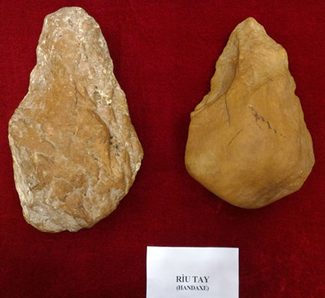

**Vietnam discovers likely most ancient early Paleolithic sites in central region**

Source: XINHUA | Apr 11,2016

HANOI, April 11 (Xinhua) -- Vietnam for the first time discovered early Paleolithic sites inside cultural layer with stone tools and tektites believed to date back 770,000-800,000 years ago, according to Vietnam Academy of Social Sciences (VASS) on Monday.

This is likely considered the most ancient mark ever-known on the appearance of human and their culture in Vietnam, the VASS said in Hanoi on Friday while announcing on preliminary results of archaeological study in An Khe town of Vietnam's Central Highlands Gia Lai province.

In 2014, while implementing a ministerial level scientific project, archaeologists discovered five early Paleolithic sites in An Khe town, said Nguyen Gia Doi, Deputy Director of Institute of Archaeology under the VASS.

In 2015 and early 2016, archaeologists conducted excavation and examination at the sites, collecting tektite pieces and stone artifacts, including picks, choppers, scrapers, flakes, unifacial and bifacial tools, hand axes made from quartzite, quartz pebble, among others.

All the sites have single intact cultural layer with stone objects, and no sign of kitchen, tomb or human remains yet, Doi added.

Archaeologists predicted the sites are corresponding to the period of Homo Erectus. The prediction was based on the distribution of sites which lie on the most ancient deposit in early middle Pleistocene on the terraces of Ba River dating back around one million years, said Doi.

This is a turning point in the awareness about the dawn of national history. "The finding added evidence on oldest beginning of currently known of Vietnamese history," assessed the official.